Puzzle Maps

Purchase Montessori puzzle maps:
IFIT Montessori here (good quality, reasonable pricing, sometimes high shipping costs)
Montessori Outlet here (average quality, good pricing, some shipping delays have been reported)
Adena Montessori here (unsure of quality, good pricing, efficient shipping)
Kid Advance here (good quality and pricing, efficient shipping)

DIY CONTINENTS MAP:
If you don’t have Montessori puzzle maps and cannot order them, use the continent stencils from Montessori ETC here to at least create the world map. You’ll also need a large poster board, acrylic paints, blue watercolor and a black sharpie.

- Use a large lid from a pot or a large serving plate to draw the two hemispheres.
- Use the stencils to trace the continents in their corresponding hemisphere.
- Leave the continents white and paint the oceans blue with watercolor.
- Paint the continent insets (from the ETC material) in the Montessori colors with acrylic paint:
  - Orange: North America
  - Pink: South America
  - Red: Europe
  - Yellow: Asia
  - Green: Africa
  - Brown: Oceania
  - White: Antarctica
- You can also trace, cut, and paint the continents and present them on blue circles.
- Use the painted insets and the blank map you made to present the names of the continents.
- See Activity A (below) for follow-up work idea.

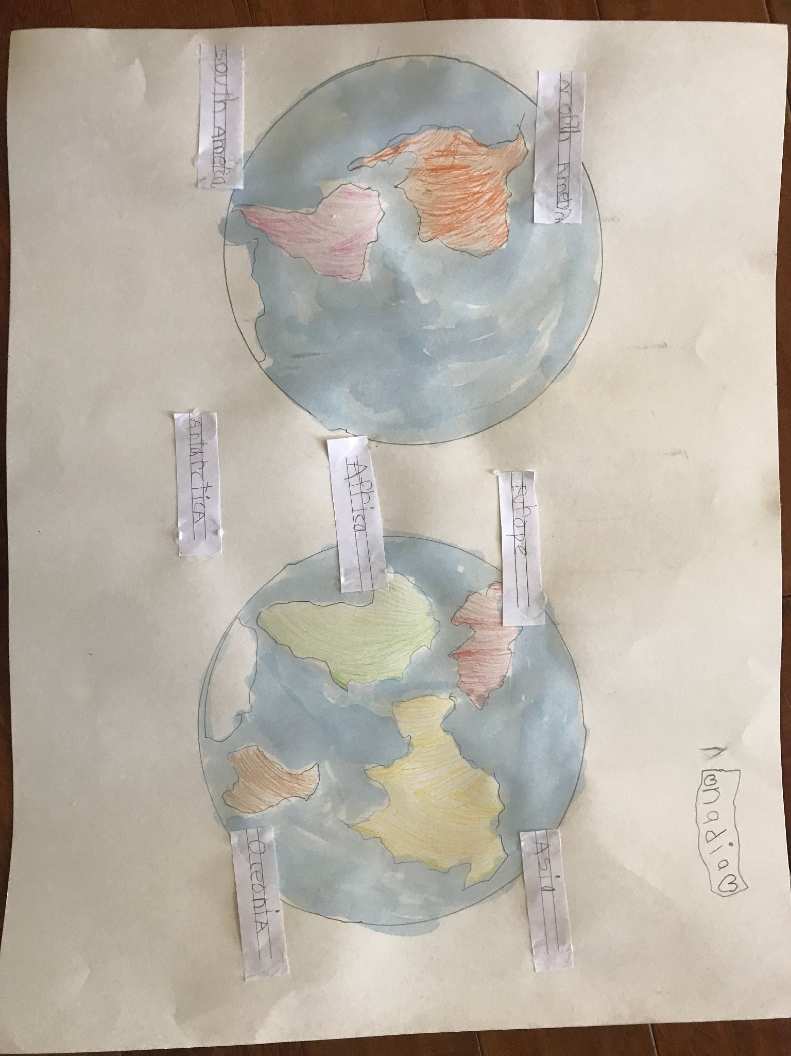
(Map follow-up created by 6-year-old child)

Presentation: World Puzzle Map
- After the child has worked with the Colored Globe in Primary, introduce him to the World Puzzle Map, using the Colored Globe as a tool for helping him understand the layout of the map.
- Use a three-period lesson to introduce the names of the continents, three at a time:
  - “This is North America. This is Europe. This is Africa.”
  - “Point to Europe. Give me Africa. Move North America here.” (repeat until you can see that the child is completing the requests correctly.)
  - “What’s this called? What’s this called?”

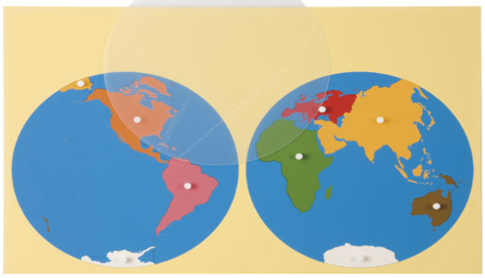

Once the child has learned the names of the continents and has done some of the activities with the world map, you can move onto the child’s continent and present in the same way.

Etymology of the names (for Elementary children):

Oceania: From the French Oceanie, it is used to describe the countries of Australia and the surrounding island nations.
America: Named after Amerigo Vespucci, whose name comes from Americus. He was a map-maker, a cartographer and because he was the first one to map the continent he got his name associated with it.
Antarctica: It means the opposite of “Arctic,” since it’s on the other side of the world from the Arctic. The word “Arctic” comes from the Latin Arctus meaning “bear”, which comes from a group of stars called the Little Bear. Antarctica is on the opposite side of where that constellation is.
Asia: From Latin, originally from Greek. Asia is thought to originate from Akkad. asu "to go out, to rise," in reference to the sun, thus "the land of the sunrise."
Africa: Feminine of Africus, from Afer "an African." Originally only in reference to the region around modern Tunisia, it gradually was extended to the whole continent.
Europe: In a Greek myth, Europa was a Phoenician princess who was taken to the island of Crete, in Greece. That area came to be known as Europe and then the name extended north.

Follow-up Activities:

Activity A: Drawing (see image above in DIY section)
- Provide a paper cut to size for the puzzle maps.
- The child can trace the outlines of the map.
- They can draw circles with the stencils.
- They can draw divisions between the continents.
- They can color the water blue and fill in the frame.
- They can label the continents if they know how to write.

Note: This is a good activity for strengthening the hand for writing for 6-year olds.

Activity B: Mathematical Aids to the Imagination

Watch an in-depth video about Mathematical Aids here.

They are a set of tables that give us statistical information about the Earth. They also include paper supplies for representing the information.
- Example: How much of the Earth is land? How much is water?
- Prepare white and blue circles using the whole of the divided circles.
- Put the white circle on the centesimal frame, mark the zero and mark how many parts correspond to the Earth’s surface (what percentage, based on data that you’ve included in a Mathematical Aids binder).
  - Mathematical Aids binder: A binder with a collection of statistics for geography (land and water percentages, populations, heights of mountains, and other information that your child might find interesting.)
  - A good children’s atlas can also provide these statistics, so you don’t NEED to have a binder.
- Next, place the blue circle in the inset and repeat for the percentage of water.
- The child will see the representation of the Earth’s proportions, which consist of 29% land and 71% water.
- Cut out the fractions for each and put them together to reproduce the whole. Write on each the percentage it represents.
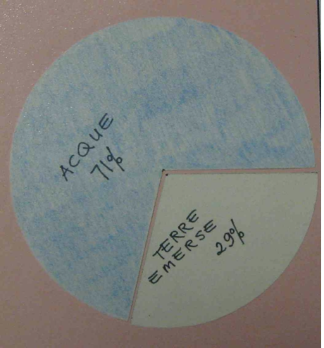
Note: When the child is young, we must provide a lot of help if he is to be successful with mathematical aids.

Activity C: Labeling map
- Provide color-coded labels for the world map: continents (yellow), oceans (blue), continents and oceans (white: not color-coded so they can be used together).
- Invite the child to read and label the continents and then the oceans. You will have two labels for Asia, Pacific and Atlantic because they are separated on the map.
- Use the blank map to work with the white labels.
- In both instances, the child can use the control map to check his work.

Presentation: The Child’s Continent
- The child can draw the map of his continent, and color/write the names of the countries and capitals.
- The child might also be interested in the etymology of the names of the countries and capital, so we’re meant to have sources where the child can check.

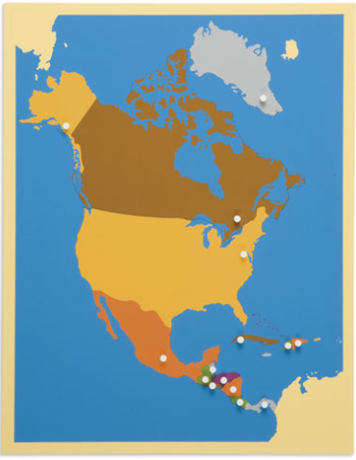

Labels for the other maps:
Any continent: countries (yellow), seas (blue), capitals (red)
Continent II (non color-coded): (in another drawer) white slips with all the countries, seas, and capitals of that continent

The child’s country: states or regions (yellow), capitals (red), seas and oceans around the country’s coastline (blue)
The child’s country II (non color-coded): (in another drawer) white slips with all the states/regions, seas/oceans, and capitals of that country

Activity: Organizing by land mass size
- Each land mass has been given its own name. They are each a continent, which comes from the word “continuous”, meaning that the land keeps going.
- The child can order the puzzle pieces representing land masses from largest to smallest.
- Then, he can look up the information to see if it corresponds to how he ordered the continents.

Activity: Proportions of Land and Water by Hemisphere
- The Earth can be divided into top and bottom parts. That would make two half-spheres called “hemispheres”.
- Invite the child to discover what continents are found in the Northern and Southern hemispheres.
- The hemispheres can be distributed by percentages of land and water.
- The child can first do a visual comparison by looking at the globe from the top-down and then from the bottom-up.
- Look up the statistical information in the Mathematical aids binder.
- Use a blue and a white circle to cut the corresponding percentages of land and water. Cut the corresponding parts to make an emphasis on the proportions.
- Finally, put the proportions together in a circle and label them.

Proportions of Land by Continent
- Asia: 29%
- Americas: 28%
- Africa: 20%
- Antarctica: 9%
- Europe: 8%
- Oceania: 6%

Presentation: Oceans

Note: We work with land first so we can identify the oceans in relation to the land masses.

PRESENTATION:
- Review the continents on the colored globe.
- Tell the child we’re going to look at the water.
- Invite the child to find the largest body of water. Note how it looks like half the Earth is made up of water if you see it on the globe.
- Point out the continents the body of water lies between.
- Say: We call it the Pacific Ocean. It’s like saying the “peaceful ocean”, but really it’s known for its tremendous storms. One of the explorers who set out to voyage around the world was named Magellan. When he entered the Pacific ocean, it happened to be peaceful so that’s why he chose that name for it.
- Invite the child to find another ocean on the other side of the world. Point out the continents it lies between.
- Say: It’s called the Atlantic Ocean because there are some mountains in Northern Africa that are called the Atlas mountains. Therefore, it is the ocean beyond the Atlas mountains.
- Say: Look at the ocean between Africa, Asia, and Oceania. Point out India. When people wanted to go from Africa to Asia they had to cross the water near India, so they called it the Indian ocean.
- Say: Look at the top of the globe. All the water is almost surrounded by land. Most of the water is frozen. The name of the ocean is the Arctic ocean and it comes from the Latin word arktos, meaning bear.
- Do a 3-period lesson with the oceans.
- Show him how on the puzzle map the Pacific and Atlantic are split in half because of how the map is cut.

Ocean Related Activities:

Activity A: Labeling
- The child can add the names of the oceans to the map he is coloring.

Presentation: The Child’s Own Country
- Use the blank map if the child is going to explore sensorially before learning the language.
- Start by teaching the name of the child’s region/state; he can use the control map to teach himself, too.

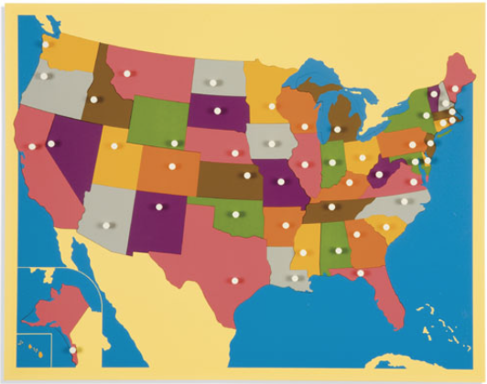

Note: It is important for the adult to transmit the knowledge of their country. You can include an interesting fact about each state/region.

